2 1CY681– Internet Protocol lab

ASSIGNMENT -6 Name: Akhil K J

Register Number : CYS22009

Title: Understanding Cisco Packet tracer

Date of Assignment provided: 17/11/2022

Aim: To study about Cisco packet Tracer

1. Getting Started with Cisco packet tracer

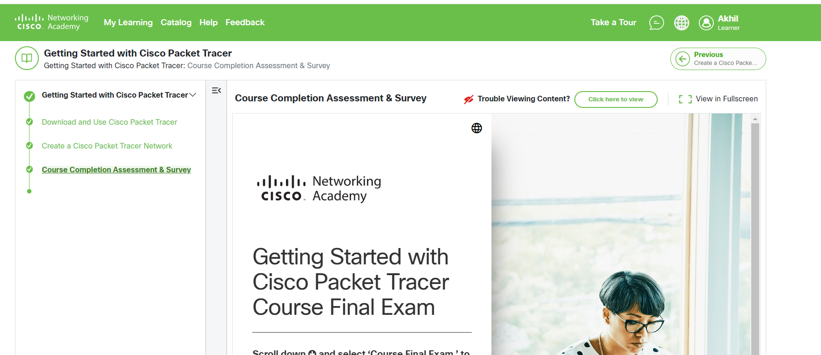

2) Exploring Network with Cisco Packet Tracer

